User Guide

December 1, 2017

Version 1.00

Document Revisions

|  |  |  |
| --- | --- | --- |
| Date | Version Number | Document Changes |
| 11/02/2017 | 0.1 | Initial Draft |
|  |  |  |
|  |  |  |
|  |  |  |
|  |  |  |
|  |  |  |
|  |  |  |
|  |  |  |
|  |  |  |

Table of Contents

1 Introduction 4

1.1 Scope and Purpose 4

1.2 Process Overview 4

# Introduction

## Scope and Purpose

The purpose of this document is to present a detailed description of the Barber Tailored Web Site being designed for Meezy Cutz. It will explain the purpose and features of the site, the interfaces of the site, what the site will do and the constraints under which it must operate. This document is intended for the Customer and the Devs. This software system will be a Website for a local Barber by Meezy Cutz. This site will be designed to maximize the business’ productivity by providing tools to assist customers with contacting the business and information as well, which would otherwise have to be performed manually. By maximizing the business’ work efficiency and production the website will meet the needs while remaining easy to understand and use.

More specifically, this Website is designed to allow a barber to manage and communicate with customers the website. The site will facilitate communication between customers and barbers via Social Media, Text, Call or E-Mail.

Features include a Google Maps Interactive Map to provide customer with location of shop, Contact information of barber, Prices of different services offered, Social Media links, a portfolio or gallery of barbers work.

Design and Implementation Constraints

The Overall Design and features of the website and heavily dependent on the time constraint given along with all the documentation needed to be provided along the way. As well as developer knowledge constraints as we will be learning along the way.

Future Enhancements

This is dependent on the barber as success or unsuccessfulness occurs the website may be changed to accompany a bigger place, more barbers and possibly even merchandise.

Software and Hardware requirements

All that is needed to develop the website is a program such as Notepad++ which will most likely be used and to use the website you will of course need an electronic device capable of getting on the internet and using a browser.

Dependencies

The website will have few dependencies but the interactive map will depend on googles servers to be working as if they are not the map may not work or will have short down time.

## Process Overview

### [Procedures for Booking an Appointment] Example: To Log in to Appointment:

1. Click Book Appointment.
2. Then Book Now.
3. Select the time best for you.
4. Enter contact info
5. Book

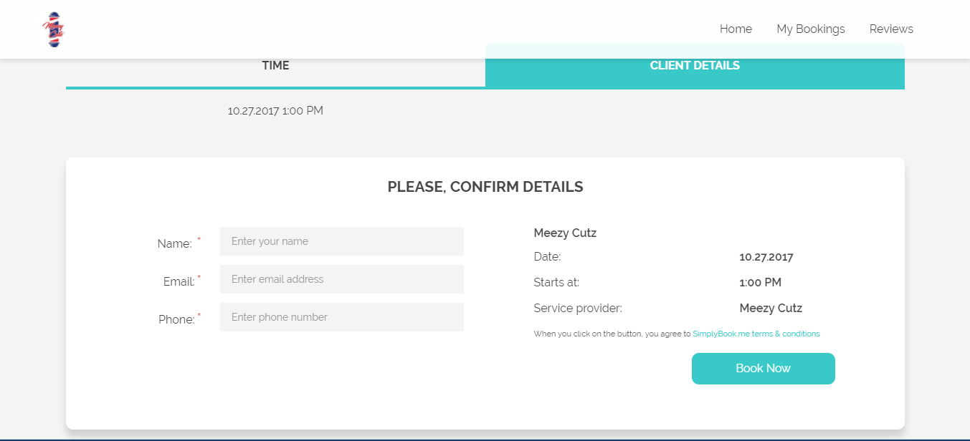

NOTE: Confirmation E-mail Will Be Sent, And if the Appointment needs to Be Canceled, Customer will be Contacted.

### [Procedures for Leaving a Comment]:

1. Leaving a Comment:
2. Enter your Name
3. Enter your E-Mail
4. Leave a Comment
5. you may have about the website or something else such as an appointment
6. Complete the action.
7. Send The E-mail

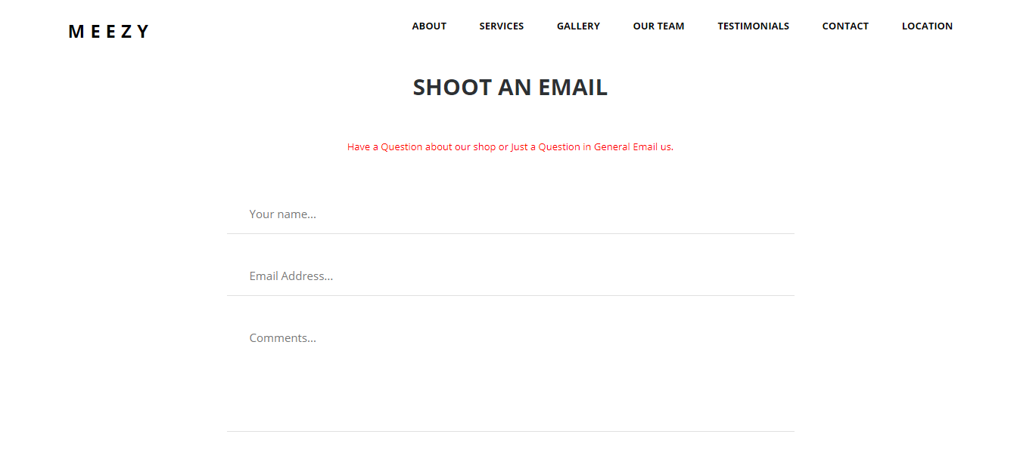

If you encounter issues not addressed by this user guide, please contact Project manager for additional support.